Grazioso Salvare AAC Dashboard

Table of Contents

- About the Project
- Development
- MongoCrud
- Dash Dashboard
- Functionality
- Tools
- Contact

About the Project
This project utilizes a Model-View-Controller (MVC) software design pattern, with a Dash dashboard (View), a MongoDB database (Model), and callback functions (Controller). Databases are used in almost every type of software application, and MongoDB is among the most popular. MongoDB is a NoSQL (Not only SQL) document-oriented database system that specializes in horizontal scaling and fast transactions. Working with MongoDB can prove to be quite tedious, and it is common for users to make mistakes when working with a command-line interface (CLI).

The Dashboard for Grazioso Salvare is designed to interact with the Austin Animal Center (AAC) ‘animals’ collection, which holds data for cats and dogs that the AAC currently houses. The dashboard integrates with the custom mongo_crud.py module’s MongoCrud class to abstract away the tedious nature of connecting to a MongoDB database and executing basic CREATE, READ, UPDATE, and DELETE (CRUD) operations. The user can create new documents to be inserted into the ‘animals’ collection of the’ AAC’ database, view (read) documents in the database by using custom query filters, update documents, and delete documents based on matching queries. More on functionality later.

Development
The connection is initialized, and the user is authenticated, upon successful execution of the program. The mongo_crud module creates a MongoClient class instance as seen below:
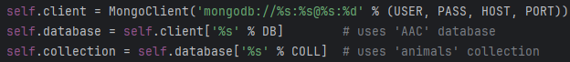
The module’s ‘create’ function performs a MongoDB ‘insert’ command:
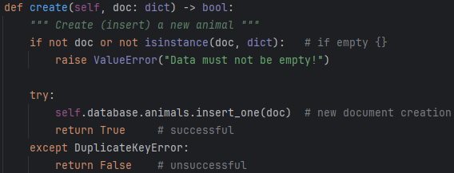
The module’s ‘read’ function performs a MongoDB ‘find’ command:
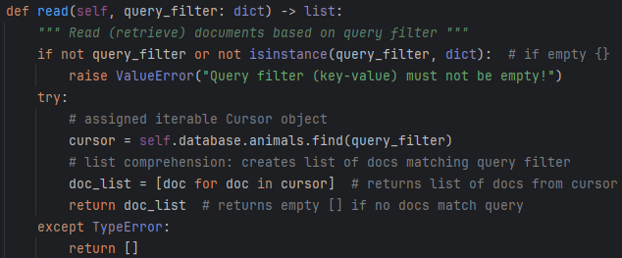
The module’s ‘update’ function performs a MongoDB ‘update_many’ command:
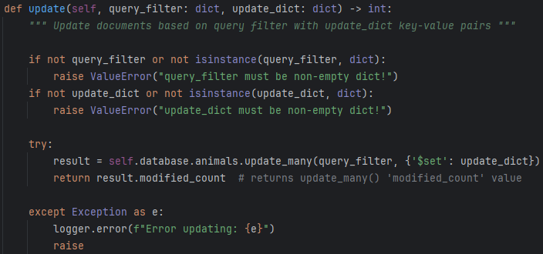
The module’s ‘delete’ function performs a MongoDB ‘delete_many’ command:
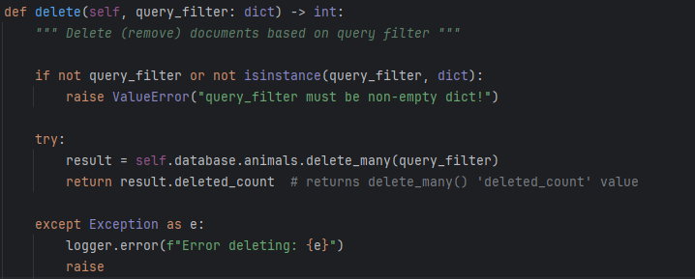

MongoCrud (mongo_crud.py)
The mongo_crud module’s MongoCrud class can be thought of as the middle “glue” layer between the MongoDB database (base level) and web app client that uses the “DASH” dashboard on the frontend.
The mongo_crud.py module should be moved to the site-packages location that contains other 3rd party modules:
- Windows:
- macOS/Linux:
OR
- virtual environment (like Anaconda):
Be sure to replace <username> with your username and ‘XX’ (or X.X) with your Python version.
PyMongo is a library with tools for working with MongoDB and is the official MongoDB driver for Python. PyMongo allows for server administration and even indexing to speed up database operations.
The mongo_crud module’s class (MongoCrud), as well as MongoClient from the PyMongo library, needs to be imported into the API being developed, as seen here:
You would also need to install PyMongo on your system, using pip or another installation method:
Now you can programmatically call the class methods from the module, based on the specific triggering mechanism(s) used in your given API or web application. Just create a MongoCrud instance:
To create a new document and insert the document into the database collection:
To access a document or group of documents by key-value pair(s):

To access the database, the user must be authenticated using a user account found in the ‘admin’ database. The ‘admin’ database uses SCRAM-SHA-256 encryption for password authentication. Currently, the user credentials are hard-coded in the dash web app; however, these strings containing credentials will be removed before deployment of the application.

The create and read functions start by ensuring the input value is not empty and is of the dict data type; otherwise, an exception is thrown:
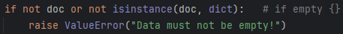

In the create function, if the data is indeed of type dict (dictionary), then the new document is inserted into the collection by using the MongoDB ‘insert_one’ function.
The read function uses a dictionary as a query filter by using the MongoDB ‘find’ function to retrieve the document as a Cursor object. I spent a bit of time struggling to find an efficient way to iterate through the Cursor object so that the queried results could be returned. To solve this problem, I ended up using a list comprehension that only took a single line of code:

If you plan on running these tests yourself (in the test_mongo_crud.py file), just make sure the mongo_crud module is installed, as well as the Python unittest library:
To run the included tests (assuming test_mongo_crud.py is located in site-packages), open your OS’s CLI, and follow the steps listed below:
- Navigate to the site-packages folder where your third-party libraries should be installed.
- Enter the following command in your CLI:
If you would like to run the tests programmatically from your API, you can simply import the test script and unittest, and execute it with code:
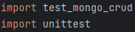

All tests should pass without error:
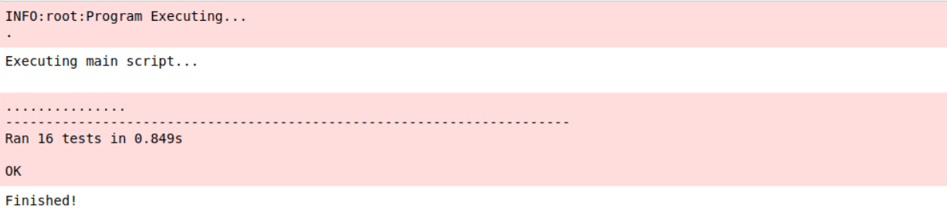

Dash Dashboard
The GUI (graphical user interface) dashboard was created using Dash from the Plotly library, along with the Python programming language and JetBrain’s PyCharm integrated development environment (IDE) and Jupyter Notebook.
To reproduce the dashboard, the appropriate libraries must be imported:
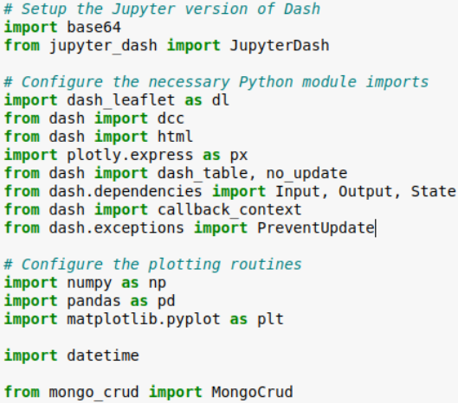

An instance of the MongoCrud class is instantiated by passing the information needed to connect to the ‘animals’ database and authenticate the user. Note that the mongo_crud module has been updated to accept all connection details as passed parameters. Instantiation and document retrieval is seen below:
A JuptyerDash instance is also created and the Grazioso Salvare logo is attempted to be loaded. In addition to checking for empty inputs and implementing standard error-catching strategies, thorough testing was done on each method in the module to ensure a robust and secure product:
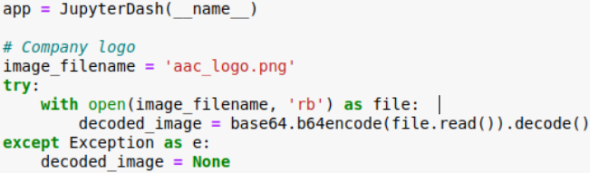

To create the View, a layout is created:
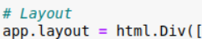

The Controller consists of a series of dynamically reactive callbacks, which process changes in user input and output the appropriate changes:

Functionality
The mongo_crud module abstracts away the tedious nature of working with a MongoDB database. The user may sort and filter the table contents or limit the number of rows (documents) displayed. A pie chart initially appears, showing the animals with the highest occurrence at the Austin Animal Center:
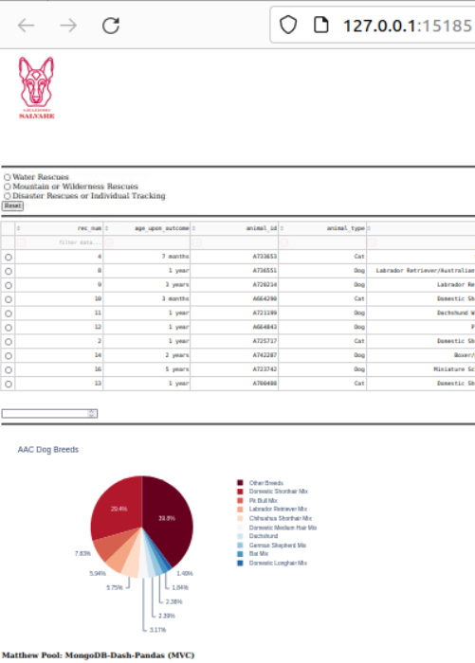
In addition, a user may select one of the displayed filter options to show preferred dog breeds (and sexes and ages) preferable for training as rescue dogs of each specified type:

Water Rescues
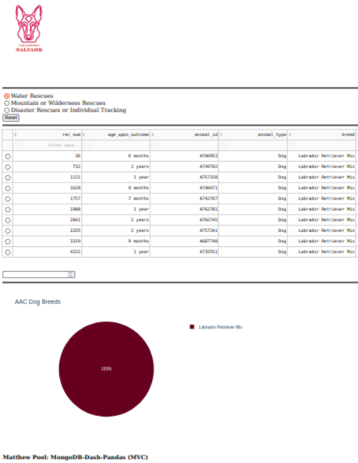

As different rescue dog types are selected, the displayed table contents and pie chart data dynamically change to reflect the corresponding option:

Mountain or Wilderness Rescues
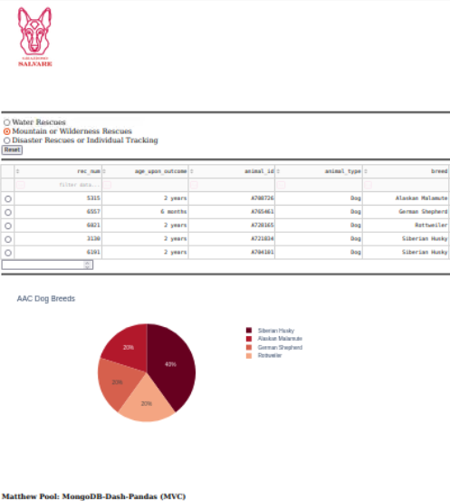

The ‘Reset’ button may be clicked to set options to their default state. Selecting an animal (row) will show a geolocation map, with the breed and name of the selected animal:

Disaster Rescues or Individual Tracking
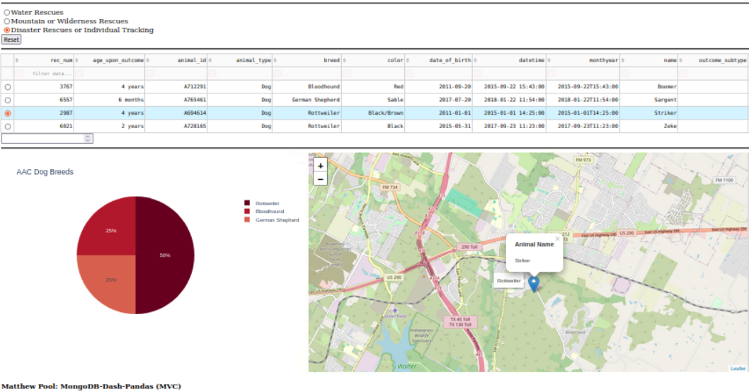

Tools














Contact
Matthew Pool
Computer Science, Southern New Hampshire University
matthew.pool@snhu.edu
April 22, 2024

